FORMATIVE 2 PART 2

1. Work through feedback
> Create a reference list / file

2.1 - Create a CSS file

2.2 - Establish a Base Style and CSS Reset

> A CSS reset helps remove default browser margins and padding so the website looks consistent across Chrome, Safari, Firefox, and Edge

> A Base Style is a set of default rues applied to the entre website so that all the pages share a consistent look and feel without needing to restyle every element manually

2.3 - Typography Styles

> The application of CSS text properties (such as font-size, weight, and line-height) to establish a clear visual hierarchy and ensure readable, aesthetically balanced content across web pages.

2.4 - Layout Structure

> A CSS layout model used to align, distribute space, and order elements efficiently within a container, even when their size is unknown or dynamic, ensuring a clean and navigable desktop structure.

2.5 - Applying Visual Style

Visual Properties (⁠border⁠, ⁠box-shadow⁠)

> These add polish to the boxes or cards, giving them borders or a subtle 3D shadow effect so they stand out from the background.

Pseudo-Classes (⁠hover⁠, ⁠focus⁠)

> These change how an element behaves when a user interacts with it—like changing a button's color when the mouse cursor rolls over it.

3.1 Breakpoints

> A specific screen width (like 768px for tablets or 480px for mobile phones) where the website's layout needs to change so it doesn't look squished.

Media Query

> A piece of CSS code that tells the browser: "If the screen size drops below X pixels, apply these specific new rules."

Responsive Column Layout

> A layout technique utilizing CSS Grid where content containers automatically shift from a multi-column structure on desktop displays to a single-column stacked layout on mobile viewports to prevent horizontal scrolling and ensure readability.

3.2 Relative Units

> By default, if an image is inserted (like a 1200px wide photo) on a mobile screen that is only 400px wide, the image will stretch past the edge of the screen and cause horizontal scrolling. Making images responsive tells the browser: "Never let this image get wider than its container, and keep its original proportions intact."

The implementation of CSS rules (⁠max-width: 100%⁠ and ⁠height: auto⁠) to ensure that embedded graphics and photos scale proportionally to fit within varying viewport widths without breaking the layout or causing horizontal scrolling.

3.4 Test and Iterate

HOMEPAGE

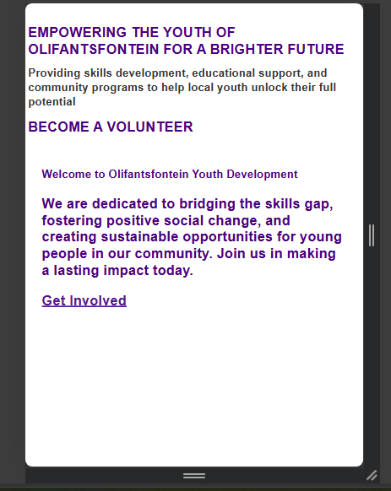

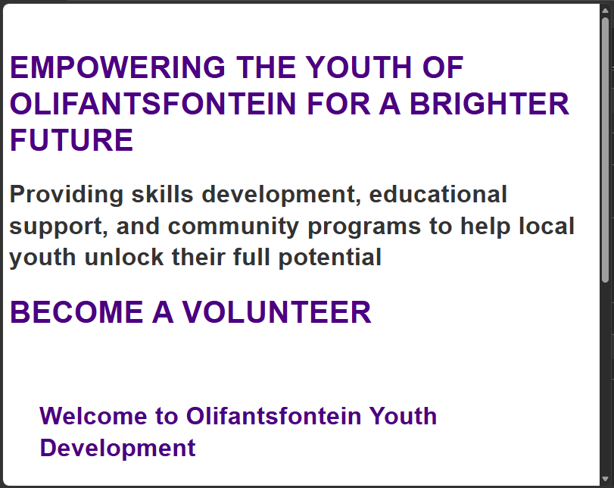

REGISTER PAGE

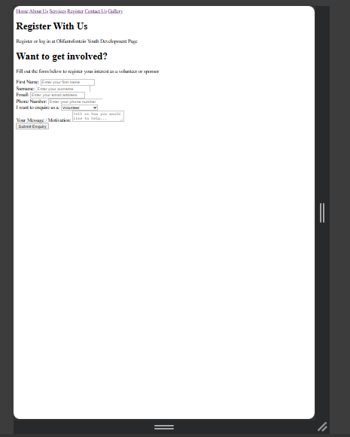

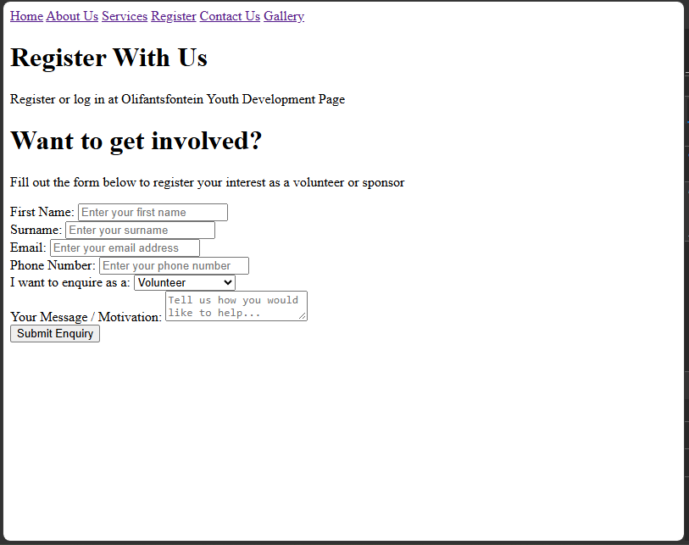

REFERENCES

Mozilla.org. (2026). CSS flexible box layout - CSS | MDN. [online] Available at: https://developer.mozilla.org/en-US/docs/Web/CSS/Guides/Flexible_box_layout [Accessed 19 Sept. 2026].

Mozilla.org. (2026). Using media queries - CSS | MDN. [online] Available at: https://developer.mozilla.org/en-US/docs/Web/CSS/Guides/Media_queries/Using [Accessed 19 Sept. 2026].

Olifantsfontein Youth Development NPC. 2026. Organization Background and Community Project Brief

W3Schools (2020). Responsive Web Design Introduction. [online] W3schools.com. Available at: https://www.w3schools.com/css/css_rwd_intro.asp [Accessed 20 Sept. 2026].

W3C (2024). Web Content Accessibility Guidelines (WCAG) Overview. [online] Web Accessibility Initiative (WAI). Available at: https://www.w3.org/WAI/standards-guidelines/wcag/ [Accessed 21 Sept. 2026].

Mozilla.org. (2026). font-size CSS property - CSS | MDN. [online] Available at: https://developer.mozilla.org/en-US/docs/Web/CSS/Reference/Properties/font-size [Accessed 20 Sept. 2026].

Mozilla.org. (2026). Basic concepts of grid layout - CSS | MDN. [online] Available at: https://developer.mozilla.org/en-US/docs/Web/CSS/Guides/Grid_layout/Basic_concepts [Accessed 21 Sept. 2026].

Mozilla.org. (2026). CSS type - CSS | MDN. [online] Available at: https://developer.mozilla.org/en-US/docs/Web/CSS/Reference/Values/color_value [Accessed 21 Sept. 2026].

Mozilla.org. (2026). Using media queries - CSS | MDN. [online] Available at: https://developer.mozilla.org/en-US/docs/Web/CSS/Guides/Media_queries/Using [Accessed 20 Sept. 2026].

Mozilla.org. (2026). CSS flexible box layout - CSS | MDN. [online] Available at: https://developer.mozilla.org/en-US/docs/Web/CSS/Guides/Flexible_box_layout [Accessed 21 Sept. 2026].

OpenAI (2025). ChatGPT. [online] ChatGPT. Available at: https://chat.openai.com/chat [Accessed 22 Sept. 2026].

